SQL Learning



Nithish Gowda

**Functions in SQL :**

**Aggregate function**

**String function**

**Date and Time Functions**

**Mathematical function**

**Conditional function**

**Window / Analytical function**

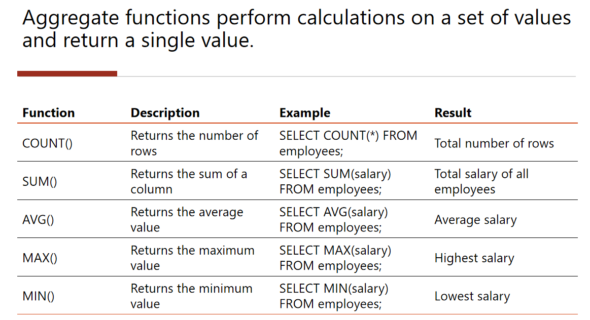

**drop table if exists products;**

**create table products(**

**product_id serial primary key,**

**product_name varchar(100),**

**category varchar(50),**

**price numeric(10,2),**

**quantity int,**

**added_date date,**

**discount_rate numeric(5,2)**

**);**

**insert into products (product_name,category,price,quantity,added_date,discount_rate) values**

**('laptop','electronics',75000.50,10,'2024-01-15',10.00),**

**('smartphone','electronics',45000.99,25,'2024-02-20',5.00),**

**('headphone','accessories',1500.75,50,'2024-03-05',15.00),**

**('office chair','furniture',5500.00,20,'2023-12-01',20.00),**

**('desk','furniture',8000.00,15,'2023-11-20',12.00),**

**('monitor','electronics',12000.00,8,'2024-01-10',8.00),**

**('printer','electronics',9500.50,5,'2024-02-01',7.50),**

**('mouse','accessories',750.00,40,'2024-03-18',10.00),**

**('keyboard','accessories',1250.00,35,'2024-03-18',10.00),**

**('tablet','electronics',30000.00,12,'2024-02-28',5.00);**

**select * from products;**

**---total quantity availabe of all products----**

**select sum(quantity) as new_quantity**

**from products;**

**---total of quantity and condition apllied--------**

**select sum(quantity) as new_quantity**

**from products**

**where category ='electronics' AND price>20000;**

**---total no of products----**

**select count (*) as total_products**

**from products;**

**---which include phone ---**

**select count (*) as total_products**

**from products**

**where product_name like '%phone';**

**--avg price of products-----**

**select avg(price) as avg_price**

**from products;**

**---avg price of products category = accessories---**

**select avg(price) as avg_price**

**from products**

**where category='accessories' or added_date>'2024-02-01';**

**----max and min price----**

**select max(price) as max_price,**

**min(price) as min_price**

**from products;**